Denis Olaïzola, MBA, CPCC, PCC  967 rue Duprat, Laval, QC, H7X 2L6  Home : (450) 314-1250 / Mobile (514) 443-8599  Email : d.olaizola@nytrox.ca | 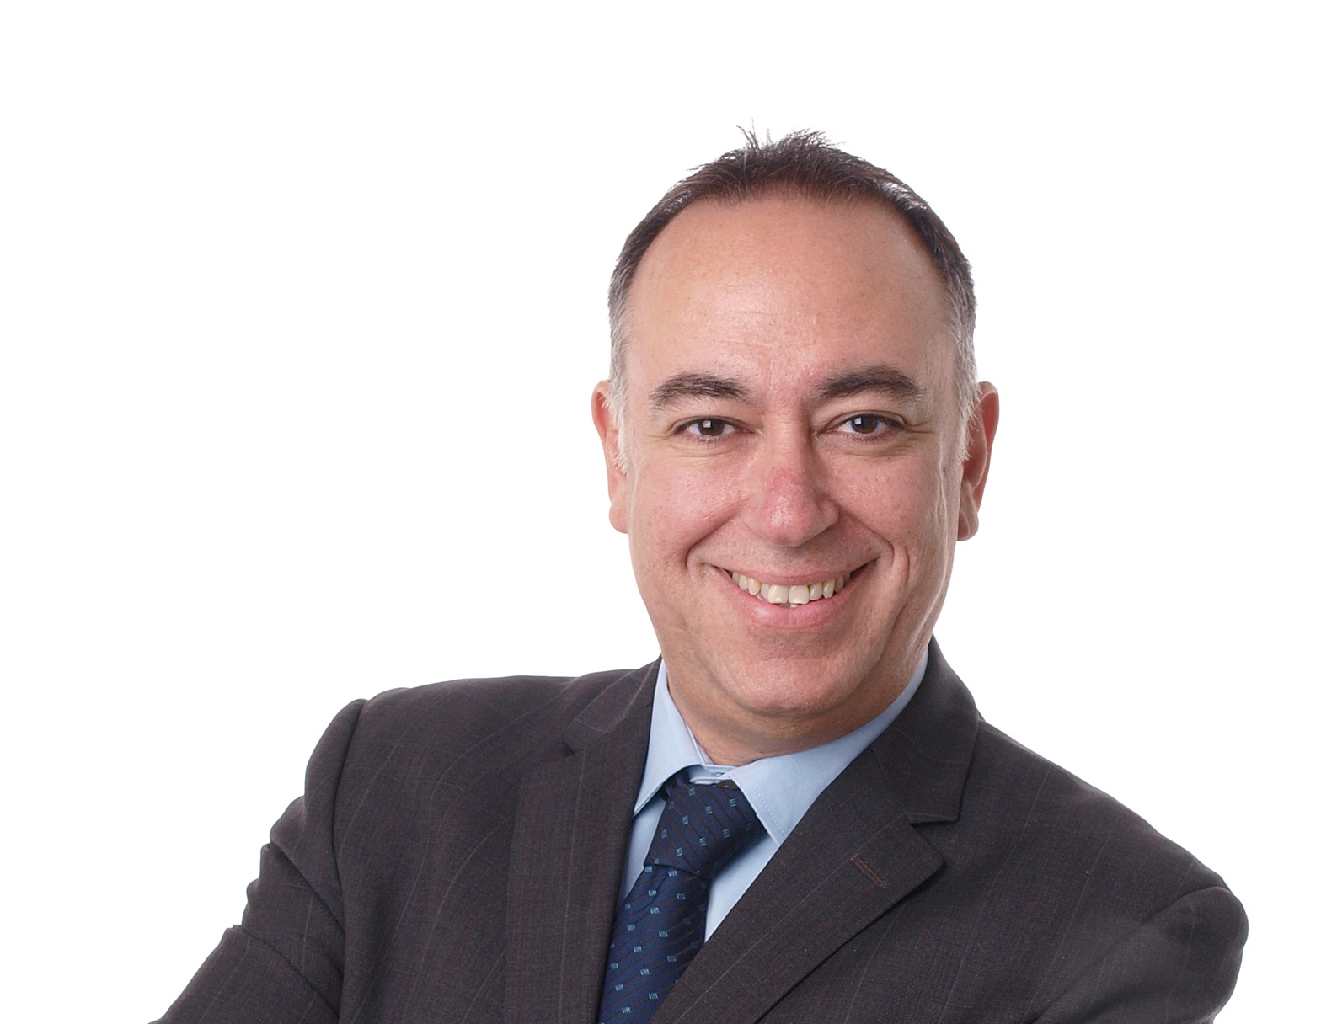

Denis has over 25 years of experience as a manager of various sectors and projects in the financial field in Montreal. He also worked in a strategic management office where his primary role was strategic human capital development and leadership development.

A passion for leadership development has enabled Denis to log more than 2000 hours of professional business and team coaching. He has helped hundreds of individuals and teams achieve their business performance objectives and develop their intra and inter team relationships to become high performing teams. As regards one-on-one coaching, Denis assists his clients in developing their leadership skills, whether by helping them to become more accountable, to engage or inspire their teams, to develop their self-confidence, to change or develop impacts on their personal and professional relationships, to reduce their stress, to realize their dreams or to achieve their personal goals.
Denis’s mantra is: Dare to release your full potential.

To remain at the leading edge of developments in human potential, Denis teaches a course on leadership, influence and change at UQAM as part of the Masters in Project Management program.

Summary of qualifications
• Executive Coach and Management
• Intervention with high-level managers / groups difficulties / crisis management
• Strategic planning, organizational development and change management
• Strategies and development programs for managers and business leaders
• Lecturer in the Master of Project Management
• Re-engineering of business processes / organizational change management
• Development and implementation of monitoring system performance management
• Project Management / Development and implementation of training program
• Intervention with high-level managers / groups difficulties / crisis management
• Development and implementation of business dashboard forward (BSC)

Training
Denis Olaïzola holds a Master of Business Administration (MBA) and a certificate in psychosocial intervention from the Université du Québec à Montréal. He is a Certified Professional Co-Active Coach (CPCC) and a graduate of the intensive leadership development program offered by the Coaches Training Institute (CTI) in California. Denis is also certified to administer the Team Diagnostic Assessment tool from Team Coaching International and have completed the program « The Co-Essence of leadership » from « Le Playground » a Paris institute.

Education
MBA - Business Administration | - UQAM 2004
Certificate in psychosocial intervention | - UQAM 1996
Certificate in Business Administration | - UQAM 1992

TRAINING SEMINARS
The co-essence of leadership | - Le Playground – Paris France (2012)
Organization and Relationship systems at work | - CRR Global – Washington DC (2011)
Team Coaching Assessment | - Team coaching International – California (2010)
Co active Leadership program | - Coaches Training Institute – California (2009)
Co active coaching Program (CPCC) | - Coaches Training Institute – California (2008)
Balanced Scorecard – How-to Training Seminar – Becoming a Strategy-Focused Organization | - Balanced Scorecard Collaborative  Washington, Dc. (2005)
Change Management : Leading Change for Organizational Success | - Conference Board of Canada Toronto – (2005)
Align Human Capital with Business Strategy | - Balanced Scorecard Collaborative - Orlando fl. (2005)
3rd Annual Balanced Scorecard for HR | - Federal Press – Toronto (2004)

Areas of intervention
Denis involved in individual and team coaching for executives, senior and middle managers and professionals to develop their leadership, interpersonal skills, managing their performance and optimize their vision and identity.
Recent coaching mandates
Client | Industry | Coaching goals
Human Resources Vice-president | Finance | Leadership, strategic vision, self confidence
Finance Manager | Financial market | Leadership, corporate image, self-confidence, self esteem
Regional Manager | Banking | Affirmative leadership, collaboration, self-affirmation
Regional Manager | Banking | Leadership, corporate image
Principal Manager | Marketing | Leadership, relational impact management
CEO | Entertainment | Managing emotions, emotional intelligence
Lawyer | Investments | Collaborative Leadership, delegation
Principal Manager | Publics services | Leadership, change management
Lawyer | Banking | Self-esteem, managing emotions, leadership style
Operations Vice-President | International | Its relational impact management
Human Resources Vice-president | Investment | Its relational impact management
IT Manager | Technology | Leadership, politic skills
Human Resources Business Partner | Investment | Strategic vision and team consolidation
Operations Manager | Investment | Collaborative leadership, organizational impact
Operations Vice-President | Operations | Affirmative leadership, organizational impact

Mandates with teams - intervention and training
Mandates | Industry
Allows over 45 leadership and management teams of a major Canadian bank and insurance companies to straighten climate, performance and cohesion to become high performing teams and achieve agreed outcomes. | Banking and insurance
Training on emotional intelligence personal and social | Corporate sector
Intervention to redress the climate and dysfunctions of the management team. | Entertainment
Training management coaching in business | Banking

Publications
- none
Conferences
• "Coaching and Project Management" PMI Continuing Education, Montreal, September 2009
• "The Art of informal influence - political and interpersonal skills," Desjardins Continuing Education, September 18, 2011

PROFESSIONAL EXPERIENCE AND ACHIEVEMENTS
Nytrox Leadership and Transformation inc.
May 2010 - to present

Company offering services to develop human capital and change management in business management through individual coaching, team building and training in the various sectors in Canada and France. Our mission is to provide quality services to support our customers in achieving their business objectives and continuous improvement of their performance.

Associate - Human Capital Development and Change Management

- Coach for executive, senior and middle management and professional
- Coach for corporate team’s development
- Consultant in change management
- Development of various coaching and training programs related to the development of Human Capital in organizations (leadership development component individual and team)
- Support and develop team performance
- Coach mentor for coaching students in the their process of obtaining certification
- Co-development trainer and facilitator for groups in corporation

University of Quebec in Montreal :
September 2008 - to present
The University of Quebec at Montreal (UQAM) is a public French-language university whose reputation is international.
Lecturer - MGP 7098 Leadership, influence and change
The course MGP 7098, focuses on the Human experiencing change, discusses methods and "special" skills require from the project manager involved as a specialist in project development, more specifically:
- Find out what is the "change" and know how to situate the proposed change in the current context of project management and change management
- Know the various models and methods of intervention in change management
- Take ownership and understand communication, leadership, power, influence, stakeholder management, etc.. mean in the context of a project that require change
- Understand what is required, from the project manager, a project of change and, among others, change yourself
International Coach Federation of Quebec: April 2010 - December 2012
The International Coach Federation of Quebec is a non-profit organization incorporated in Quebec, and the Quebec chapter of the professional association of general interest and independent named International Coach Federation (ICF).
Administrator
Member of the Executive Committee ensures the proper functioning of the Federation and ensures the implementation of decisions of the Board and the General Assembly under the control of the board. Provides support to the development of the coaching profession.
Objectives of the mandate of FICQ
Promote coaching in Quebec offering coaches throughout the country and especially by regional sections, exchange places, healing and professional work and public recognition of the coaching profession.
National Bank Financial Group:
1990 - May 2010
Company offering brokerage services and administration to financial institutions in the securities industry in Canada. The company is a division of National Bank of Canada, National Bank Financial Group has more than 550 employees located in Canada and Europe.
Senior Advisor, Change Management and Management Coach and Leadership Development - 2003 - 2010

- As head of change management, team member of the Leaders Institute of the company, my primary mandate was to ensure the organizational development of human capital and develop management to be aligned with organizational strategies
- Responsible for developing various training programs related to leadership development for all executives and managers
- Advises senior management in the interpretation and application of the various programs and policies of human resources in line with the corporate strategy.
Manager, various operational areas (Administration of accounts, transfer accounts, year-end processing) 1999-2003
Senior Business Analyst - 1997-1999
Supervisor, Service Development Registered Plans, Dividends and Interest, Immigrant Investor Service - 1990-1997

